Digital Image

Processing
CS 457
Semester 7th
DIP Practical Task 09

Download ten 8-bit grayscale images of size 500x500.
import os from PIL import Image import numpy as np import matplotlib.pyplot as plt
# Function to resize images to a specific size (500x500 by default) def process_and_resize_images(image_files, resize_dim=(500, 500)):
resized_imgs = [] for file_path in image_files:
# Open the image and convert it to grayscale img = Image.open(file_path).convert('L') # Resize the image to the target dimension resized_img = img.resize(resize_dim)
# Append the resized image (as a numpy array) to the list resized_imgs.append(np.array(resized_img))
print(f"Images resized to {resize_dim}") return resized_imgs

Implement the lossless predictive coding using:

(a) simplest predictor (fx+1 = fx)
# Simplest Predictor (predicting based on the previous pixel in the row) def simplest_predictor(image):
predicted_values = np.zeros_like(image, dtype=int) error_values = np.zeros_like(image, dtype=int) rows, cols = image.shape
# Iterate over each row and column, starting from the second column for row in range(rows): for col in range(1, cols): # Skip the first column as there's no
previous pixel to compare predicted_values[row, col] = image[row, col - 1] # The
prediction is based on the previous pixel error_values[row, col] = np.abs(image[row, col] -
predicted_values[row, col]) # Calculate the absolute error print("Task 1 (a): Simplest predictor applied successfully") return error_values

(b) median of 3 pixels
# Median Predictor (prediction based on the median of the two preceding pixels) def median_predictor(image):
predicted_values = np.zeros_like(image, dtype=int)
error_values = np.zeros_like(image, dtype=int) rows, cols = image.shape
# Loop through each row and column, starting from the third column for row in range(rows): for col in range(2, cols): # Begin from the third column, as there are two previous pixels
# Predict the pixel value using the median of the two previous
pixels predicted_values[row, col] = int(np.median([image[row, col - 1],
image[row, col - 2]]))
# Calculate the error as the absolute difference between the
actual and predicted values error_values[row, col] = np.abs(image[row, col] -
predicted_values[row, col]) print("Task 1 (b): Median predictor successfully applied") return error_values
(c) one other predictor of your own choice
# Custom Predictor (prediction using a weighted combination of the previous pixel and the pixel above) def custom_predictor(image):
predicted_values = np.zeros_like(image, dtype=int) error_values = np.zeros_like(image, dtype=int) rows, cols = image.shape
# Iterate over each row and column, starting from the second column for row in range(rows):
for col in range(1, cols):
# Calculate the predicted value as a weighted average of the
previous pixel and the one above (if exists) predicted_values[row, col] = int(0.5 * image[row, col - 1] + 0.5
* (image[row - 1, col] if row > 0 else 0))
# Compute the error as the difference between the actual and
predicted values error_values[row, col] = image[row, col] - predicted_values[row,
col] print("Task 1 (c): Custom predictor successfully applied") return error_values
# Function to plot the original image and the error images for different predictors def plot_images(original, simplest_error, median_error, custom_error):
plt.figure(figsize=(18, 6)) # Plot original image onc
ubplot(1, 4, 1) plt.title("Original Image") plt.imshow(original, cmap='gray') plt.axis('off') # Hide axes for clarity

# Plot error from Simplest Predictor plt.subplot(1, 4, 2)
plt.title("Simplest Predictor Error") plt.imshow(simplest_error, cmap='gray') plt.axis('off')

# Plot error from Median Predictor plt.subplot(1, 4, 3)
plt.title("Median Predictor Error") plt.imshow(median_error, cmap='gray') plt.axis('off')
# Plot error from Custom Predictor plt.subplot(1, 4, 4)
plt.title("Custom Predictor Error") plt.imshow(custom_error, cmap='gray') plt.axis('off')
# Show all the plots together plt.show()

# Main function to process the images def main():
image_folder = r"/Images"

# List all files in the directory and filter by common image extensions valid_extensions = ['.jpeg', '.png', '.jpg', '.bmp', '.gif'] image_paths = [os.path.join(image_folder, f) for f in
os.listdir(image_folder) if any(f.endswith(ext) for ext in valid_extensions)]
if not image_paths:
print("No valid images found in the specified directory.") return
# Resize images to 500x500
images = process_and_resize_images(image_paths) # Process and plot results for each image for idx, img in enumerate(images):
print(f"Processing Image {idx + 1}") # Apply predictors and calculate errors simplest_error = simplest_predictor(img) median_error = median_predictor(img) custom_error = custom_predictor(img)
# Plot the original image and the errors for each predictor plot_images(img, simplest_error, median_error, custom_error)
# Run the main function if name == " main ": main()
Images resized to (500, 500)
Processing Image 1
Task 1 (a): Simplest predictor applied successfully
Task 1 (b): Median predictor successfully applied
Task 1 (c): Custom predictor successfully applied

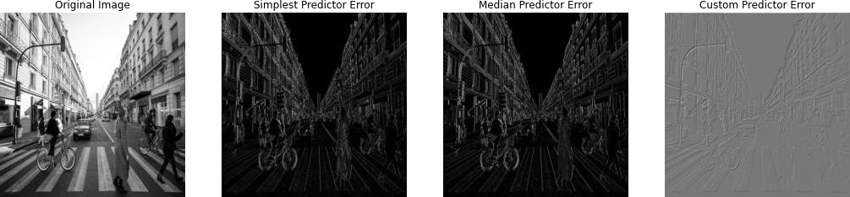

Processing Image 2
Task 1 (a): Simplest predictor applied successfully
Task 1 (b): Median predictor successfully applied
Task 1 (c): Custom predictor successfully applied

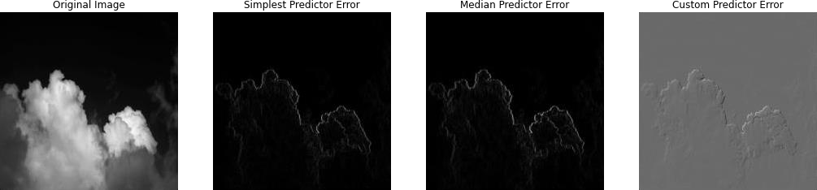

Processing Image 3
Task 1 (a): Simplest predictor applied successfully
Task 1 (b): Median predictor successfully applied
Task 1 (c): Custom predictor successfully applied
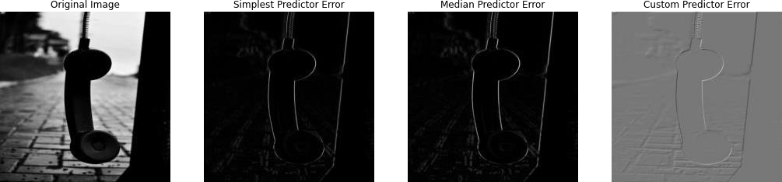

Processing Image 4
Task 1 (a): Simplest predictor applied successfully
Task 1 (b): Median predictor successfully applied
Task 1 (c): Custom predictor successfully applied

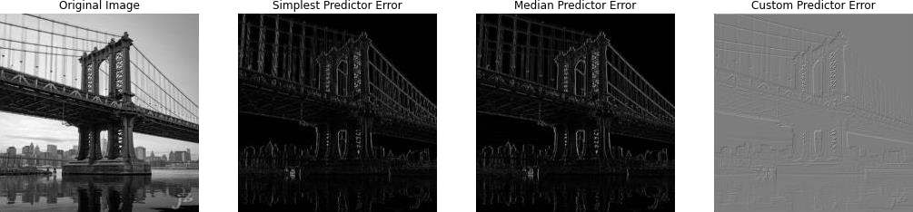

Processing Image 5
Task 1 (a): Simplest predictor applied successfully
Task 1 (b): Median predictor successfully applied
Task 1 (c): Custom predictor successfully applied

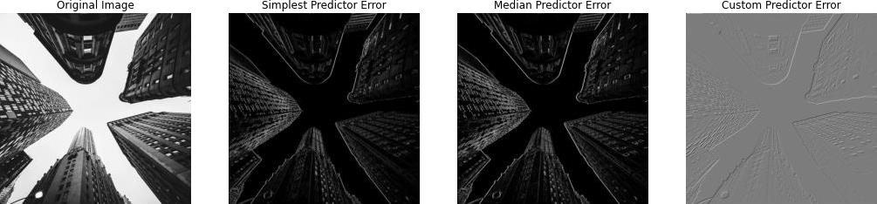

Processing Image 6
Task 1 (a): Simplest predictor applied successfully
Task 1 (b): Median predictor successfully applied
Task 1 (c): Custom predictor successfully applied
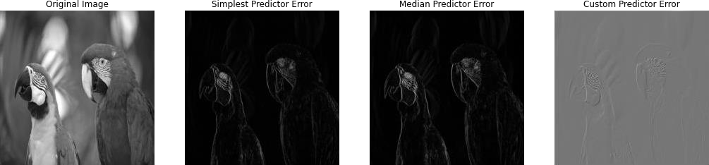
Processing Image 7
Task 1 (a): Simplest predictor applied successfully
Task 1 (b): Median predictor successfully applied
Task 1 (c): Custom predictor successfully applied

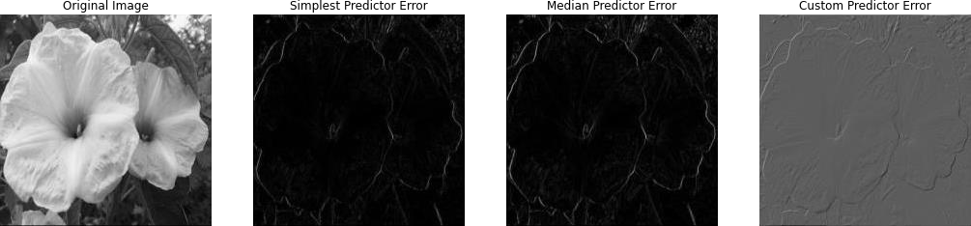

Processing Image 8
Task 1 (a): Simplest predictor applied successfully
Task 1 (b): Median predictor successfully applied
Task 1 (c): Custom predictor successfully applied

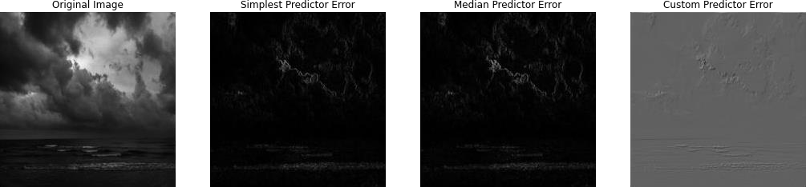

Processing Image 9
Task 1 (a): Simplest predictor applied successfully
Task 1 (b): Median predictor successfully applied
Task 1 (c): Custom predictor successfully applied

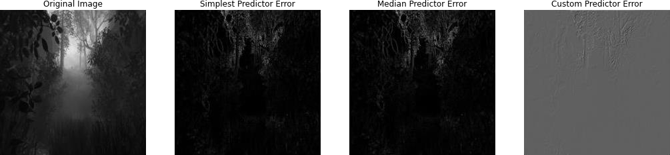

Processing Image 10
Task 1 (a): Simplest predictor applied successfully
Task 1 (b): Median predictor successfully applied
Task 1 (c): Custom predictor successfully applied
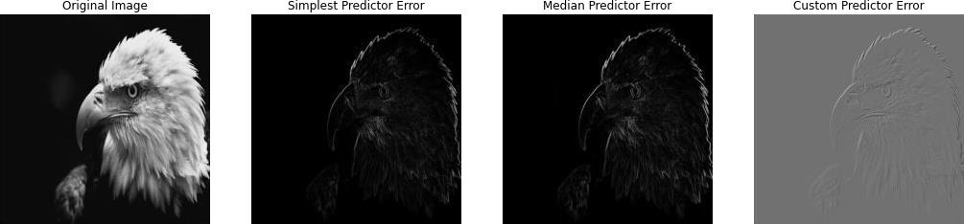

After the predictive coding, use Huffman coding for the final compressed output and calculate the compression ratio.

import os
from collections import Counter import heapq import numpy as np from PIL import Image

class HuffmanNode:
def init (self, freq, symbol=None, left=None, right=None):
self.freq = freq self.symbol = symbol self.left = left self.right = right
def lt (self, other):
return self.freq < other.freq

def build_huffman_tree(frequencies):
heap = [HuffmanNode(freq, symbol) for symbol, freq in
frequencies.items()] heapq.heapify(heap)
while len(heap) > 1:
left = heapq.heappop(heap) right = heapq.heappop(heap)
merged = HuffmanNode(left.freq + right.freq, left=left, right=right) heapq.heappush(heap, merged)
return heap[0]

def generate_huffman_codes(node, prefix="", codes={}):
if node.symbol is not None:
codes[node.symbol] = prefix return codes
if node.left: generate_huffman_codes(node.left, prefix + "0", codes)
if node.right: generate_huffman_codes(node.right, prefix + "1", codes)

return codes

def main():
# Set the folder path for images image_folder = r"\Images"

# List all files in the directory and filter by common image extensions valid_extensions = ['.jpeg', '.png', '.jpg', '.bmp', '.gif'] image_paths = [os.path.join(image_folder, f) for f in
os.listdir(image_folder) if any(f.endswith(ext) for ext in valid_extensions)]
if not image_paths:
print("No valid images found in the specified directory.") return

# Resize images to 500x500 images = resize_images(image_paths)

# Apply Huffman Coding using Simplest Predictor
print("\nApplying Huffman Coding using Simplest Predictor...") main_huffman(images, simplest_predictor)

# Run the main function if name == " main ":
main()

Applying Huffman Coding using Simplest Predictor...
Processing Image 1

Original Image Size (bytes): 250000
Encoded Data Length: 1518694 bits
Compression Ratio: 1.32

Sample Huffman Codes:
Symbol: -18, Code: 0000000
Symbol: -33, Code: 00000010
Symbol: 35, Code: 00000011
Symbol: -91, Code: 00000100000
Symbol: 109, Code: 000001000010

Processing Image 2

Original Image Size (bytes): 250000
Encoded Data Length: 683431 bits
Compression Ratio: 2.93

Sample Huffman Codes:
Symbol: -18, Code: 01100101001
Symbol: -33, Code: 0110010111011
Symbol: 35, Code: 0011010110101
Symbol: -91, Code: 00000100000
Symbol: 109, Code: 000001000010

Processing Image 3

Original Image Size (bytes): 250000
Encoded Data Length: 826839 bits
Compression Ratio: 2.42

Sample Huffman Codes:
Symbol: -18, Code: 1001100010
Symbol: -33, Code: 1101111100110
Symbol: 35, Code: 1101101000111
Symbol: -91, Code: 110111111000101
Symbol: 109, Code: 1101100011100111

Processing Image 4

Original Image Size (bytes): 250000
Encoded Data Length: 1347655 bits
Compression Ratio: 1.48

Sample Huffman Codes:
Symbol: -18, Code: 10110100
Symbol: -33, Code: 010111011
Symbol: 35, Code: 010110111
Symbol: -91, Code: 0101101101010
Symbol: 109, Code: 11010100010010

Processing Image 5

Original Image Size (bytes): 250000
Encoded Data Length: 1328473 bits Compression Ratio: 1.51

Sample Huffman Codes:
Symbol: -18, Code: 10001101
Symbol: -33, Code: 001110110
Symbol: 35, Code: 001110100
Symbol: -91, Code: 101100110111
Symbol: 109, Code: 010010101001

Processing Image 6

Original Image Size (bytes): 250000
Encoded Data Length: 1098556 bits Compression Ratio: 1.82

Sample Huffman Codes:
Symbol: -18, Code: 010010000
Symbol: -33, Code: 00101001111
Symbol: 35, Code: 01001000100
Symbol: -91, Code: 100000101001001
Symbol: 109, Code: 100110100101110

Processing Image 7

Original Image Size (bytes): 250000
Encoded Data Length: 1099681 bits Compression Ratio: 1.82

Sample Huffman Codes:
Symbol: -18, Code: 001001000
Symbol: -33, Code: 00011111000
Symbol: 35, Code: 00010001011
Symbol: -91, Code: 101001101100111011 Symbol: 109, Code: 10100110101001010

Processing Image 8

Original Image Size (bytes): 250000
Encoded Data Length: 786871 bits
Compression Ratio: 2.54

Sample Huffman Codes:
Symbol: -18, Code: 011100101100
Symbol: -33, Code: 0110101101110110
Symbol: 35, Code: 100011011111001
Symbol: -91, Code: 101001101100111011 Symbol: 109, Code: 10100110101001010

Processing Image 9

Original Image Size (bytes): 250000
Encoded Data Length: 1052793 bits
Compression Ratio: 1.90

Sample Huffman Codes:
Symbol: -18, Code: 001000101
Symbol: -33, Code: 00100011100
Symbol: 35, Code: 00111101001
Symbol: -91, Code: 00111111101011111
Symbol: 109, Code: 10100110101001010

Processing Image 10

Original Image Size (bytes): 250000
Encoded Data Length: 880080 bits
Compression Ratio: 2.27

Sample Huffman Codes:
Symbol: -18, Code: 011110101
Symbol: -33, Code: 0000010111
Symbol: 35, Code: 01001010110
Symbol: -91, Code: 00110011000010
Symbol: 109, Code: 001100110000110

Apply Huffman coding on the original images as well and calculate the compression ratio.

import os
from collections import Counter import heapq import numpy as np

from PIL import Image

class HuffmanNode:
def init (self, freq, symbol=None, left=None, right=None):
self.freq = freq self.symbol = symbol self.left = left self.right = right
def lt (self, other):
return self.freq < other.freq

def build_huffman_tree(frequencies):
heap = [HuffmanNode(freq, symbol) for symbol, freq in
frequencies.items()] heapq.heapify(heap)
while len(heap) > 1:
left = heapq.heappop(heap) right = heapq.heappop(heap)
merged = HuffmanNode(left.freq + right.freq, left=left, right=right) heapq.heappush(heap, merged)
return heap[0]

def generate_huffman_codes(node, prefix="", codes={}):
if node.symbol is not None:
codes[node.symbol] = prefix return codes
if node.left: generate_huffman_codes(node.left, prefix + "0", codes)
if node.right: generate_huffman_codes(node.right, prefix + "1", codes)

return codes

def huffman_compress(data):
flattened_data = data.flatten() frequencies = Counter(flattened_data) huffman_tree = build_huffman_tree(frequencies) codes = generate_huffman_codes(huffman_tree)
encoded_data = "".join(codes[value] for value in flattened_data) return frequencies, codes, encoded_data
def calculate_compression_ratio(original_size, encoded_data): compressed_size = len(encoded_data) / 8 compression_ratio = original_size / compressed_size return compression_ratio

def simplest_predictor(image):
rows, cols = image.shape
prediction_error = np.zeros((rows, cols), dtype=np.int16) for i in range(rows):
for j in range(cols):
if j == 0: # First column, no left pixel prediction_error[i, j] = image[i, j]
else:
prediction_error[i, j] = int(image[i, j]) - int(image[i, j -
1]) return prediction_error

def resize_images(image_paths, size=(500, 500)):
images = [] for path in image_paths:
img = Image.open(path).convert("L").resize(size) images.append(np.array(img))
return images

def main_huffman(images, predictor):
for idx, img in enumerate(images):
print(f"\nProcessing Image {idx + 1}") print("-" * 50)

# Calculate original image size
original_size = img.shape[0] * img.shape[1] # width * height from
numpy array shape

# Huffman coding for the original image
_, orig_codes, orig_encoded_data = huffman_compress(img) orig_compression_ratio = calculate_compression_ratio(original_size,
orig_encoded_data)

print(f"Original Image Compression Ratio:
{orig_compression_ratio:.2f}") print("\nSample Huffman Codes for Original Image:") for symbol, code in list(orig_codes.items())[:5]:
print(f" Symbol: {symbol}, Code: {code}")

print("-" * 50)
# Prediction error using the provided predictor prediction_error = predictor(img)

# Huffman coding for the prediction error
_, pred_codes, pred_encoded_data = huffman_compress(prediction_error) pred_compression_ratio = calculate_compression_ratio(original_size,
pred_encoded_data)
print(f"Prediction Error Compression Ratio:
{pred_compression_ratio:.2f}") print("\nSample Huffman Codes for Prediction Error:") for symbol, code in list(pred_codes.items())[:5]:
print(f" Symbol: {symbol}, Code: {code}")
print("-" * 50)

def main():
# Set the folder path for images
image_folder = r"E:\University\7th Semester\DIP Lab\Lab 9\Images"

# List all files in the directory and filter by common image extensions valid_extensions = ['.jpeg', '.png', '.jpg', '.bmp', '.gif'] image_paths = [os.path.join(image_folder, f) for f in
os.listdir(image_folder) if any(f.endswith(ext) for ext in valid_extensions)]
if not image_paths:
print("No valid images found in the specified directory.") return

# Resize images to 500x500 images = resize_images(image_paths)

# Apply Huffman Coding using Simplest Predictor
print("\nApplying Huffman Coding on Original and Prediction Error
Images...") main_huffman(images, simplest_predictor)

# Run the main function if name == " main ":
main()

Applying Huffman Coding on Original and Prediction Error Images...
Processing Image 1

Original Image Compression Ratio: 1.02
Sample Huffman Codes for Original Image:
Symbol: 77, Code: 0000000
Symbol: 83, Code: 0000001
Symbol: 234, Code: 00000100
Symbol: 20, Code: 00000101
Symbol: 76, Code: 0000011

Prediction Error Compression Ratio: 1.32

Sample Huffman Codes for Prediction Error:
Symbol: 77, Code: 11100000011
Symbol: 83, Code: 10011010011
Symbol: 234, Code: 1010000101110001
Symbol: 20, Code: 11100100
Symbol: 76, Code: 11111011010

Processing Image 2

Original Image Compression Ratio: 1.19

Sample Huffman Codes for Original Image:
Symbol: 77, Code: 011100111
Symbol: 83, Code: 110010000
Symbol: 234, Code: 010101110111
Symbol: 20, Code: 11101000
Symbol: 76, Code: 100101111

Prediction Error Compression Ratio: 2.93

Sample Huffman Codes for Prediction Error:
Symbol: 77, Code: 01100110110111000
Symbol: 83, Code: 110010000
Symbol: 234, Code: 010101110111
Symbol: 20, Code: 011011111000
Symbol: 76, Code: 011001101111010010

Processing Image 3

Original Image Compression Ratio: 1.20

Sample Huffman Codes for Original Image:
Symbol: 77, Code: 111001000 Symbol: 83, Code: 101011101 Symbol: 234, Code: 110001
Symbol: 20, Code: 111111111
Symbol: 76, Code: 111011001

Prediction Error Compression Ratio: 2.42

Sample Huffman Codes for Prediction Error: Symbol: 77, Code: 11101011000010001
Symbol: 83, Code: 1101111110100011
Symbol: 234, Code: 110001
Symbol: 20, Code: 11011111000
Symbol: 76, Code: 10011001100010

Processing Image 4

Original Image Compression Ratio: 1.02

Sample Huffman Codes for Original Image:
Symbol: 77, Code: 10100110
Symbol: 83, Code: 10010001
Symbol: 234, Code: 0011011
Symbol: 20, Code: 11110101
Symbol: 76, Code: 11001100

Prediction Error Compression Ratio: 1.48

Sample Huffman Codes for Prediction Error:
Symbol: 77, Code: 101001101110
Symbol: 83, Code: 1000101001100
Symbol: 234, Code: 101000100011111000
Symbol: 20, Code: 10001110
Symbol: 76, Code: 101001101111

Processing Image 5

Original Image Compression Ratio: 1.13

Sample Huffman Codes for Original Image:
Symbol: 77, Code: 00100000
Symbol: 83, Code: 111010010
Symbol: 234, Code: 0101100 Symbol: 20, Code: 0111111
Symbol: 76, Code: 00010110

Prediction Error Compression Ratio: 1.51

Sample Huffman Codes for Prediction Error:
Symbol: 77, Code: 10011000000
Symbol: 83, Code: 00001101111
Symbol: 234, Code: 0101100
Symbol: 20, Code: 01101101
Symbol: 76, Code: 01101110101

Processing Image 6

Original Image Compression Ratio: 1.09

Sample Huffman Codes for Original Image:
Symbol: 77, Code: 1110001
Symbol: 83, Code: 1111000
Symbol: 234, Code: 0000111100
Symbol: 20, Code: 11001111011011010
Symbol: 76, Code: 1101000

Prediction Error Compression Ratio: 1.82

Sample Huffman Codes for Prediction Error:
Symbol: 77, Code: 10010110110111
Symbol: 83, Code: 0010100010011
Symbol: 234, Code: 0000111100
Symbol: 20, Code: 001010000
Symbol: 76, Code: 0100100110011

Processing Image 7

Original Image Compression Ratio: 1.04

Sample Huffman Codes for Original Image:
Symbol: 77, Code: 10011100
Symbol: 83, Code: 01111001
Symbol: 234, Code: 00100001111
Symbol: 20, Code: 00101110
Symbol: 76, Code: 10011101

Prediction Error Compression Ratio: 1.82

Sample Huffman Codes for Prediction Error: Symbol: 77, Code: 101011101100000 Symbol: 83, Code: 101011101101111
Symbol: 234, Code: 00100001111
Symbol: 20, Code: 1010111010
Symbol: 76, Code: 00010001010100

Processing Image 8

Original Image Compression Ratio: 1.18
Sample Huffman Codes for Original Image:
Symbol: 77, Code: 10110100
Symbol: 83, Code: 10000000
Symbol: 234, Code: 00100001111
Symbol: 20, Code: 111100
Symbol: 76, Code: 10100111

Prediction Error Compression Ratio: 2.54

Sample Huffman Codes for Prediction Error:
Symbol: 77, Code: 10110100
Symbol: 83, Code: 10000000
Symbol: 234, Code: 00100001111
Symbol: 20, Code: 01101010100 Symbol: 76, Code: 10100111

Processing Image 9

Original Image Compression Ratio: 1.24

Sample Huffman Codes for Original Image:
Symbol: 77, Code: 011001010
Symbol: 83, Code: 101110001
Symbol: 234, Code: 00100001111
Symbol: 20, Code: 111110
Symbol: 76, Code: 110000000

Prediction Error Compression Ratio: 1.90

Sample Huffman Codes for Prediction Error: Symbol: 77, Code: 1100101111110000
Symbol: 83, Code: 1100101111110101
Symbol: 234, Code: 00100001111
Symbol: 20, Code: 000100011
Symbol: 76, Code: 001000100110011

Processing Image 10

Original Image Compression Ratio: 1.59

Sample Huffman Codes for Original Image:
Symbol: 77, Code: 1111001111
Symbol: 83, Code: 1111001001
Symbol: 234, Code: 1001011
Symbol: 20, Code: 111101010
Symbol: 76, Code: 101100010

Prediction Error Compression Ratio: 2.27

Sample Huffman Codes for Prediction Error:
Symbol: 77, Code: 01101100111110
Symbol: 83, Code: 0110111110111001
Symbol: 234, Code: 1001011
Symbol: 20, Code: 011001011
Symbol: 76, Code: 01011011100010

For all 10 images, report the results of compression with and without predictive coding.

import os
from collections import Counter import heapq import numpy as np from PIL import Image from tabulate import tabulate # For better table formatting
class HuffmanNode:
def init (self, freq, symbol=None, left=None, right=None):
self.freq = freq self.symbol = symbol self.left = left self.right = right
def lt (self, other):
return self.freq < other.freq

def build_huffman_tree(frequencies):
heap = [HuffmanNode(freq, symbol) for symbol, freq in
frequencies.items()] heapq.heapify(heap)
while len(heap) > 1:
left = heapq.heappop(heap) right = heapq.heappop(heap)
merged = HuffmanNode(left.freq + right.freq, left=left, right=right) heapq.heappush(heap, merged)
return heap[0]

def generate_huffman_codes(node, prefix="", codes={}):
if node.symbol is not None: codes[node.symbol] = prefix return codes
if node.left: generate_huffman_codes(node.left, prefix + "0", codes)
if node.right: generate_huffman_codes(node.right, prefix + "1", codes)

return codes

def huffman_compress(data):
flattened_data = data.flatten() frequencies = Counter(flattened_data) huffman_tree = build_huffman_tree(frequencies) codes = generate_huffman_codes(huffman_tree)
encoded_data = "".join(codes[value] for value in flattened_data) return frequencies, codes, encoded_data
def calculate_compression_ratio(original_size, encoded_data): compressed_size = len(encoded_data) / 8 compression_ratio = original_size / compressed_size return compression_ratio

def simplest_predictor(image):
rows, cols = image.shape
prediction_error = np.zeros((rows, cols), dtype=np.int16) for i in range(rows):
for j in range(cols):
if j == 0: # First column, no left pixel prediction_error[i, j] = image[i, j]
else:
prediction_error[i, j] = int(image[i, j]) - int(image[i, j -
1]) return prediction_error

def resize_images(image_paths, size=(500, 500)):
images = [] for path in image_paths:
img = Image.open(path).convert("L").resize(size) images.append(np.array(img))
return images

def main_huffman(images, predictor):
results = []
for idx, img in enumerate(images): print(f"\nProcessing Image {idx + 1}") print("-" * 50)

# Calculate original image size
original_size = img.shape[0] * img.shape[1] # width * height from
numpy array shape

# Huffman coding for the original image
_, orig_codes, orig_encoded_data = huffman_compress(img) orig_compression_ratio = calculate_compression_ratio(original_size,
orig_encoded_data)

print(f"Original Image Compression Ratio:
{orig_compression_ratio:.2f}")

results.append({
"image": idx + 1,
"original_compression_ratio": orig_compression_ratio,
"prediction_error_compression_ratio": None, })

print("\nSample Huffman Codes for Original Image:") for symbol, code in list(orig_codes.items())[:5]:
print(f" Symbol: {symbol}, Code: {code}")
print("-" * 50)

# Calculate prediction error using the predictor prediction_error = predictor(img)

# Huffman coding for the prediction error
_, pred_codes, pred_encoded_data = huffman_compress(prediction_error) pred_compression_ratio = calculate_compression_ratio(original_size,
pred_encoded_data)

print(f"Prediction Error Compression Ratio:
{pred_compression_ratio:.2f}") print("\nSample Huffman Codes for Prediction Error:") for symbol, code in list(pred_codes.items())[:5]:
print(f" Symbol: {symbol}, Code: {code}")
print("-" * 50)

# Store the results
results[-1]["prediction_error_compression_ratio"] =
pred_compression_ratio
return results

def main():
# Set the folder path for images
image_folder = r"E:\University\7th Semester\DIP Lab\Lab 9\Images"

# List all files in the directory and filter by common image extensions valid_extensions = ['.jpeg', '.png', '.jpg', '.bmp', '.gif'] image_paths = [os.path.join(image_folder, f) for f in
os.listdir(image_folder) if any(f.endswith(ext) for ext in valid_extensions)]
if not image_paths:
print("No valid images found in the specified directory.") return

# Resize images to 500x500 images = resize_images(image_paths)

# Apply Huffman Coding using Simplest Predictor
print("\nApplying Huffman Coding on Original and Prediction Error
Images...") results = main_huffman(images, simplest_predictor)
# Prepare the summary data for table display summary_data = [
[result["image"], f"{result['original_compression_ratio']:.2f}", f"{result['prediction_error_compression_ratio']:.2f}"] for result in results ]

# Print the summary table
print("\nSummary of Compression Results:")
headers = ["Image", "Original Compression Ratio", "Prediction Error
Compression Ratio"] print(tabulate(summary_data, headers=headers, tablefmt="grid"))

# Run the main function if name == " main ":
main()

Applying Huffman Coding on Original and Prediction Error Images...
Processing Image 1

Original Image Compression Ratio: 1.02

Sample Huffman Codes for Original Image: Symbol: 77, Code: 0000000
Symbol: 83, Code: 0000001
Symbol: 234, Code: 00000100
Symbol: 20, Code: 00000101
Symbol: 76, Code: 0000011

Prediction Error Compression Ratio: 1.32

Sample Huffman Codes for Prediction Error:
Symbol: 77, Code: 11100000011
Symbol: 83, Code: 10011010011
Symbol: 234, Code: 1010000101110001
Symbol: 20, Code: 11100100
Symbol: 76, Code: 11111011010

Processing Image 2

Original Image Compression Ratio: 1.19

Sample Huffman Codes for Original Image:
Symbol: 77, Code: 011100111
Symbol: 83, Code: 110010000
Symbol: 234, Code: 010101110111
Symbol: 20, Code: 11101000
Symbol: 76, Code: 100101111

Prediction Error Compression Ratio: 2.93

Sample Huffman Codes for Prediction Error:
Symbol: 77, Code: 01100110110111000
Symbol: 83, Code: 110010000
Symbol: 234, Code: 010101110111
Symbol: 20, Code: 011011111000
Symbol: 76, Code: 011001101111010010

Processing Image 3

Original Image Compression Ratio: 1.20

Sample Huffman Codes for Original Image:
Symbol: 77, Code: 111001000 Symbol: 83, Code: 101011101
Symbol: 234, Code: 110001
Symbol: 20, Code: 111111111
Symbol: 76, Code: 111011001

Prediction Error Compression Ratio: 2.42 Sample Huffman Codes for Prediction Error: Symbol: 77, Code: 11101011000010001
Symbol: 83, Code: 1101111110100011
Symbol: 234, Code: 110001
Symbol: 20, Code: 11011111000
Symbol: 76, Code: 10011001100010

Processing Image 4

Original Image Compression Ratio: 1.02

Sample Huffman Codes for Original Image:
Symbol: 77, Code: 10100110
Symbol: 83, Code: 10010001
Symbol: 234, Code: 0011011
Symbol: 20, Code: 11110101
Symbol: 76, Code: 11001100

Prediction Error Compression Ratio: 1.48

Sample Huffman Codes for Prediction Error:
Symbol: 77, Code: 101001101110
Symbol: 83, Code: 1000101001100
Symbol: 234, Code: 101000100011111000
Symbol: 20, Code: 10001110
Symbol: 76, Code: 101001101111

Processing Image 5

Original Image Compression Ratio: 1.13

Sample Huffman Codes for Original Image:
Symbol: 77, Code: 00100000
Symbol: 83, Code: 111010010
Symbol: 234, Code: 0101100 Symbol: 20, Code: 0111111
Symbol: 76, Code: 00010110

Prediction Error Compression Ratio: 1.51

Sample Huffman Codes for Prediction Error:
Symbol: 77, Code: 10011000000
Symbol: 83, Code: 00001101111
Symbol: 234, Code: 0101100
Symbol: 20, Code: 01101101
Symbol: 76, Code: 01101110101

Processing Image 6

Original Image Compression Ratio: 1.09

Sample Huffman Codes for Original Image:
Symbol: 77, Code: 1110001
Symbol: 83, Code: 1111000
Symbol: 234, Code: 0000111100
Symbol: 20, Code: 11001111011011010
Symbol: 76, Code: 1101000

Prediction Error Compression Ratio: 1.82

Sample Huffman Codes for Prediction Error:
Symbol: 77, Code: 10010110110111
Symbol: 83, Code: 0010100010011
Symbol: 234, Code: 0000111100
Symbol: 20, Code: 001010000
Symbol: 76, Code: 0100100110011

Processing Image 7

Original Image Compression Ratio: 1.04

Sample Huffman Codes for Original Image:
Symbol: 77, Code: 10011100
Symbol: 83, Code: 01111001
Symbol: 234, Code: 00100001111
Symbol: 20, Code: 00101110
Symbol: 76, Code: 10011101

Prediction Error Compression Ratio: 1.82

Sample Huffman Codes for Prediction Error: Symbol: 77, Code: 101011101100000 Symbol: 83, Code: 101011101101111
Symbol: 234, Code: 00100001111
Symbol: 20, Code: 1010111010
Symbol: 76, Code: 00010001010100

Processing Image 8

Original Image Compression Ratio: 1.18

Sample Huffman Codes for Original Image: Symbol: 77, Code: 10110100
Symbol: 83, Code: 10000000
Symbol: 234, Code: 00100001111
Symbol: 20, Code: 111100
Symbol: 76, Code: 10100111

Prediction Error Compression Ratio: 2.54

Sample Huffman Codes for Prediction Error:
Symbol: 77, Code: 10110100
Symbol: 83, Code: 10000000
Symbol: 234, Code: 00100001111
Symbol: 20, Code: 01101010100 Symbol: 76, Code: 10100111

Processing Image 9

Original Image Compression Ratio: 1.24

Sample Huffman Codes for Original Image:
Symbol: 77, Code: 011001010
Symbol: 83, Code: 101110001
Symbol: 234, Code: 00100001111
Symbol: 20, Code: 111110
Symbol: 76, Code: 110000000

Prediction Error Compression Ratio: 1.90

Sample Huffman Codes for Prediction Error: Symbol: 77, Code: 1100101111110000
Symbol: 83, Code: 1100101111110101
Symbol: 234, Code: 00100001111
Symbol: 20, Code: 000100011
Symbol: 76, Code: 001000100110011

Processing Image 10

Original Image Compression Ratio: 1.59

Sample Huffman Codes for Original Image:
Symbol: 77, Code: 1111001111 Symbol: 83, Code: 1111001001
Symbol: 234, Code: 1001011
Symbol: 20, Code: 111101010
Symbol: 76, Code: 101100010

Prediction Error Compression Ratio: 2.27
Sample Huffman Codes for Prediction Error:
Symbol: 77, Code: 01101100111110
Symbol: 83, Code: 0110111110111001
Symbol: 234, Code: 1001011
Symbol: 20, Code: 011001011
Symbol: 76, Code: 01011011100010

Summary of Compression Results:
+ + +
---+
| Image | Original Compression Ratio | Prediction Error Compression Ratio |
+=========+==============================+=================================== ===+
| 1 | 1.02 |
1.32 |
+ + +
---+
| 2 | 1.19 |
2.93 |
+ + +
---+
| 3 | 1.2 |
2.42 |
+ + +
---+
| 4 | 1.02 |
1.48 |
+ + +
---+
| 5 | 1.13 |
1.51 |
+ + +
---+
| 6 | 1.09 |
1.82 |
+ + +
---+
| 7 | 1.04 |
1.82 |
+ + +
---+
| 8 | 1.18 |
2.54 |
+ + +
---+
| 9 | 1.24 |
1.9 |
+ + +
---+
| 10 | 1.59 |
2.27 |
+ + +
---+

